**Wazuh on proxmox Installation guide:**

1. Open any browser and search for WAZUH installation

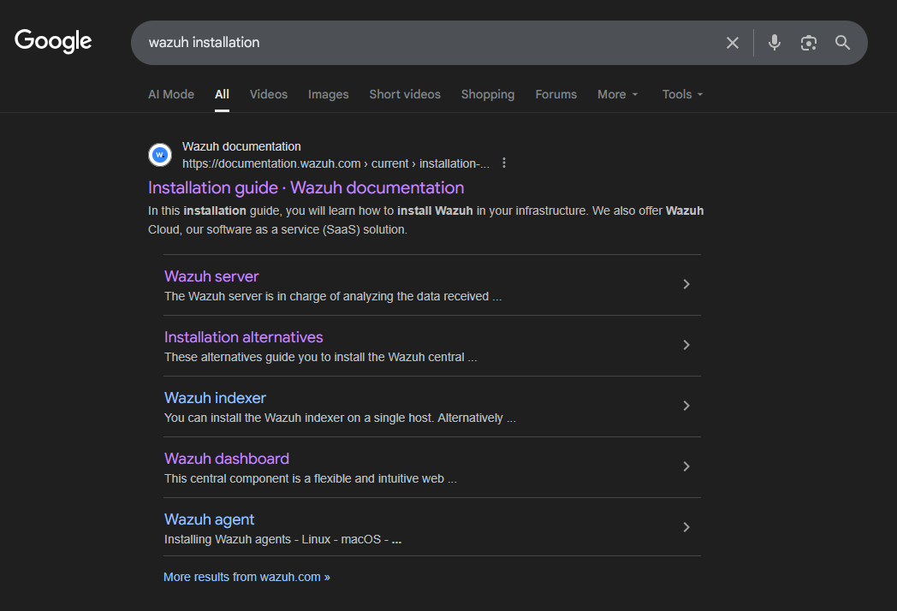

1. click Installation Alternatives > click virtual machine (OVA)

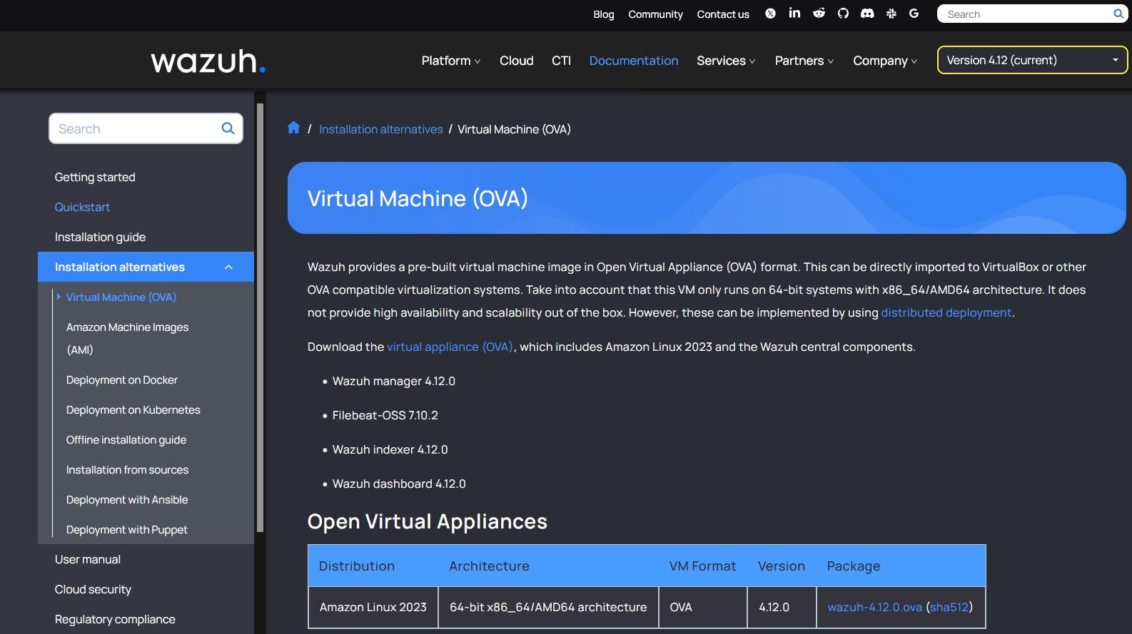

1. On the package - Right click on wazuh-4.12.0.ova right click and select copy link.

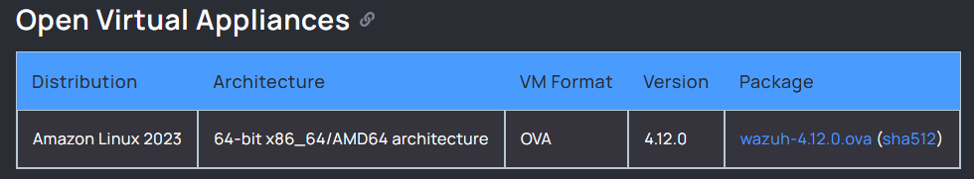

1. Next - open PROXMOX server > select the node > select shell

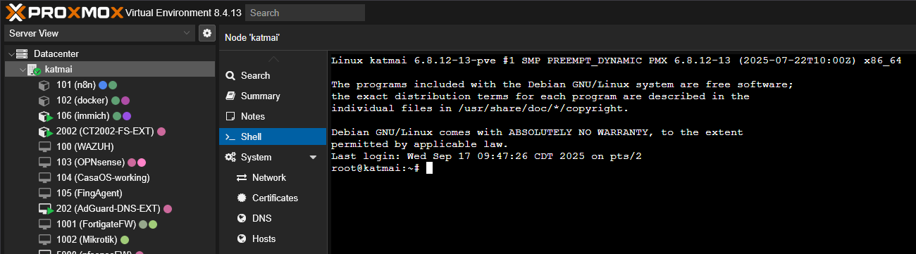

1. Please navigate to /var/lib/vz and create a folder for the .ova file container.
2. on the shell prompt type cd /var/lib/vz
3. type mkdir folder
4. type cd folder
5. After creating the folder. Run the command

wget <https://packages.wazuh.com/4.x/vm/wazuh-4.12.0.ova>

Wait until the package fully downloaded.

1. Once downloaded. Extract the OVA file by running the command tar –xvf wazuh-4.12.0.ova

There are 3 files with different file extensions: .ovf, .vmdk, .mf

1. On your PROXMOX Server create VM 107
2. Run this command qm importdisk 107 wazuh-4.12.0.vmdk SharedDrive